Understanding and Practicing on the Noble Eightfold Path

Table of Contents

Introduction to the Noble Eightfold Path 2
The Heart of the Buddha’s Teaching 2
The Wheel of Dharma 2
Understanding and Working with Causes and Conditions 3
Right View 5
Right Intention/Right Resolve 6
Right Speech 6
Right Action 7
Discussion; Q&A; 5 min bio break 9
15-20 min Mindfulness Meditation 9
Right Livelihood 10
Right Effort 10
Right Mindfulness 10
Right Concentration 11
Weaving the Eightfold Path into Everyday Life 11

About the Study Session Materials
Tipitaka – baskets, the earliest teachings (three baskets: sutta basket, poetry basket, basket of rules for monks/nuns). The sutta basket contains these groups of suttas, which number to nearly 2000):
- Digha Nikaya (DN) — the "long collection"
- Majjhima Nikaya (MN) — the "middle-length collection"
- Samyutta Nikaya (SN) — the "grouped collection"
- Anguttara Nikaya (AN)— the "further-factored collection" or the Numbered Collection (i.e. the Book of Ones, the Book of Twos, the Books of Threes, Fours, ….)
- Khuddaka Nikaya — the "collection of little texts":

Books and websites referenced for Commentary and exegesis:

- The Heart of the Buddha’s Teaching, Thich Nhat Hanh
- Mindfulness: A Practical Guide to Awakening, Joseph Goldstein
- What the Buddha Taught, Richard Gombrich
- https://www.accesstoinsight.org/ati/tipitaka/
- https://suttacentral.net/pitaka

Introduction to the Noble Eightfold Path

Today we discuss the heart of the Buddha’s teaching: Ways to reduce mental suffering / stress / dis-ease by cultivating the eight steps in the Buddha’s Noble Eightfold path. We start with an overview and some review of the core Buddhist teachings on the Four Noble Truths.

The Heart of the Buddha’s Teaching

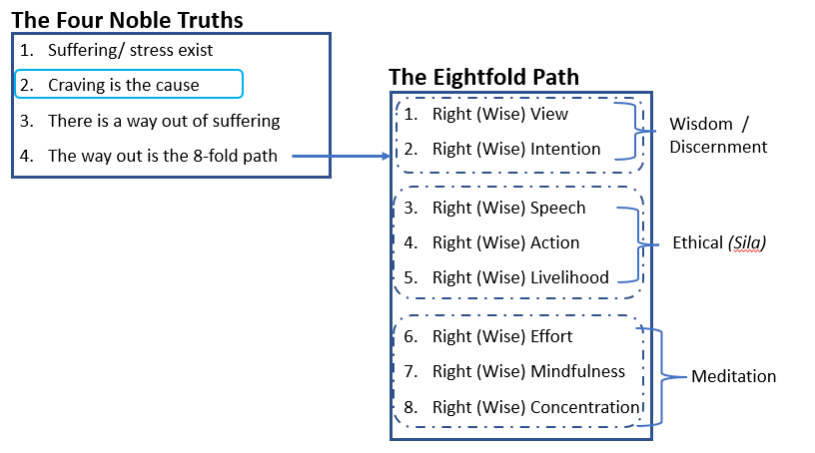
By “practicing,” we mean reflecting and cultivating the skillful teachings advised at each step – or set of steps – on the path. With Wisdom and Discernment, we set our course, the tone of our journey; we set our intention to reduce or avoid causing suffering for ourselves or others; with the ethical factors, we apply care to our actions and intentions; meditation and concentration reinforce what we learn; gentle, pointed effort is required at every step.

The path is not linear though right view and right intention are essential for laying the course; other than that, the steps weave and reinforce one another as we practice in daily life.

The Wheel of Dharma

As we learn – gain insight into the world of our experience – the wheel of dharma turns us toward and through each Noble Truth. Because it is a wheel, it cycles, and with each turn, we learn more, grow more, transform. Sometimes, like a wheel, we reverse, we back step; then move forward again. Reflecting on and acting

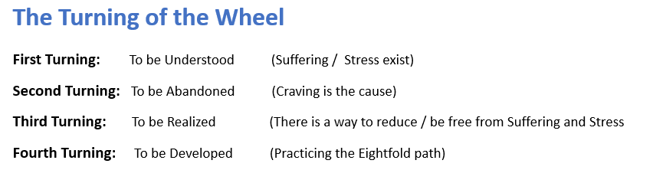

Understanding and Working with Causes and Conditions

These are the obstacles and hindrances we will find on our path; our goal is to be mindful of them to reduce the suffering or stress our encounters with them can generate. The factors on the EightFold path, when cultivated, help us combat them with wisdom and more skillful behavior.
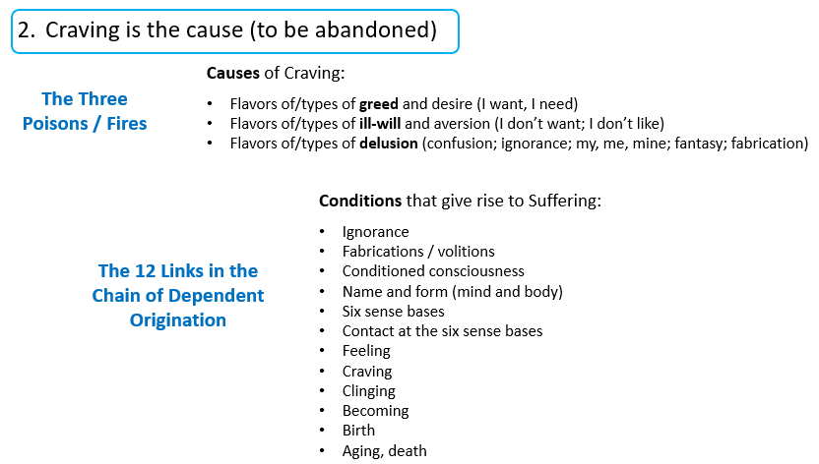

SN 45:8 Magga-Vibhaṅga Sutta / An Analysis of the Path

Trans. Bhikkhu Sujato

"I have heard that at one time the Blessed One was staying near Sāvatthī in Jeta’s Grove, Anāthapiṇḍika’s monastery. There he addressed the monks, “Monks!”

“Yes, lord,” the monks responded to him.

The Blessed One said, “I will teach & analyze for you the noble eightfold path. Listen & pay close attention. I will speak.”

“As you say, lord,” the monks responded to him.

The Blessed One said, “Now what, monks, is the noble eightfold path? Right view, right resolve, right speech, right action, right livelihood, right effort, right mindfulness, right concentration.

“And what, monks, is right view? Knowledge with regard to stress, knowledge with regard to the origination of stress, knowledge with regard to the stopping of stress, knowledge with regard to the way of practice leading to the stopping of stress: This, monks, is called right view. [Right View = knowledge of the Four Noble Truths].

“And what, monks, is right resolve? Resolve for renunciation, resolve for non-ill will, resolve for harmlessness: This, monks, is called right resolve.

“And what, monks, is right speech? Abstaining from lying, abstaining from divisive speech, abstaining from harsh speech, abstaining from idle chatter: This, monks, is called right speech.

“And what, monks, is right action? Abstaining from taking life, abstaining from stealing, abstaining from sexual [misconduct]: This, monks, is called right action.

“And what, monks, is right livelihood? There is the case where a disciple of the noble ones, having abandoned dishonest livelihood, keeps his life going with right livelihood. This, monks, is called right livelihood.

“And what, monks, is right effort? [The four right efforts: to guard against arising; to abandon; to cultivate; to sustain]: (i) There is the case where a monk generates desire, endeavors, activates persistence, upholds & exerts his intent for the sake of the non-arising of evil, unskillful qualities that have not yet arisen. (ii) He generates desire, endeavors, activates persistence, upholds & exerts his intent for the sake of the abandoning of evil, unskillful qualities that have arisen. (iii) He generates desire, endeavors, activates persistence, upholds & exerts his intent for the sake of the arising of skillful qualities that have not yet arisen. (iv) He generates desire, endeavors, activates persistence, upholds & exerts his intent for the maintenance, non-confusion, increase, plenitude, development, & culmination of skillful qualities that have arisen. This, monks, is called right effort.

“And what, monks, is right mindfulness? [The Four Foundations of Mindfulness: of body, of feeling, of mind states, of mental objects] There is the case where a monk remains focused on the body in & of itself—ardent, alert, & mindful—subduing greed & distress with reference to the world. He remains focused on feelings in & of themselves—ardent, alert, & mindful—subduing greed & distress with reference to the world. He remains focused on the mind in & of itself—ardent, alert, & mindful—subduing greed & distress with reference to the world. He remains focused on mental qualities in & of themselves—ardent, alert, & mindful—subduing greed & distress with reference to the world. This, monks, is called right mindfulness.

“And what, monks, is right concentration? There is the case where a monk—quite secluded from sensuality,6 secluded from unskillful qualities—enters & remains in the first jhāna: rapture & pleasure born of seclusion, accompanied by directed thought & evaluation. With the stilling of directed thoughts & evaluations, he enters & remains in the second jhāna: rapture & pleasure born of concentration, unification of awareness free from directed thought & evaluation—internal assurance. With the fading of rapture, he remains equanimous, mindful, & alert, and senses pleasure with the body. He enters & remains in the third jhāna, of which the noble ones declare, ‘Equanimous & mindful, he has a pleasant abiding.’ (iv) With the abandoning of pleasure & pain—as with the earlier disappearance of elation & distress—he enters & remains in the fourth jhāna: purity of equanimity & mindfulness, neither pleasure nor pain. This, monks, is called right concentration.”

That is what the Blessed One said. Gratified, the monks delighted in the Blessed One’s words.”

Right View

Right view is key for multiple reasons:

- It sets the stage for transformation from suffering into freedom of mind – we see the dharma and understand the need for practice
- Wrong views are at the root of suffering so again, awareness guides our progress in understanding, practicing, making effort to transform habitual patterns into freer ways of living – detachment from views of self and various aspects of our experience

MN 9 Sammādiṭṭhi Sutta / Right View

In this sutta, Ven. Sāriputta says, “When a disciple of the noble ones discerns what is unskillful, discerns the root of what is unskillful, discerns what is skillful, and discerns the root of what is skillful, it is to that extent that he is a person of right view, one whose view is made straight, who is endowed with verified confidence in the Dhamma, and who has arrived at this true Dhamma.

“And what is unskillful? Taking life is unskillful, taking what is not given… sexual misconduct… lying… divisive speech… harsh speech… idle chatter is unskillful. Covetousness… ill will… wrong views are unskillful. These things are called unskillful.

“And what are the roots of what is unskillful? Greed is a root of what is unskillful, aversion is a root of what is unskillful, delusion is a root of what is unskillful. These are called the roots of what is unskillful.

“And what is skillful? Abstaining from taking life is skillful, abstaining from taking what is not given… from sexual misconduct… from lying… from divisive speech… from harsh speech… abstaining from idle chatter is skillful. Lack of covetousness… lack of ill will… right views are skillful. These things are called skillful.

“And what are the roots of what is skillful? Lack of greed is a root of what is skillful, lack of aversion… lack of delusion is a root of what is skillful. These are called the roots of what is skillful.

“When a disciple of the noble ones discerns what is unskillful in this way, discerns the root of what is unskillful in this way, discerns what is skillful in this way, and discerns the root of what is skillful in this way, when—having entirely abandoned passion-obsession, having abolished aversion-obsession, having uprooted the view-&-conceit obsession ‘I am’; having abandoned ignorance & given rise to clear knowing—he has put an end to suffering & stress right in the here & now, it is to this extent that a disciple of the noble ones is a person of right view, one whose view is made straight, who is endowed with verified confidence in the Dhamma, and who has arrived at this true Dhamma.”

Commentary

In the chapter on Right View in The Heart of the Buddha’s Teaching, Thich Nhat Hanh says:

“Buddhism is not a collection of views. It is a practice to help us eliminate wrongs views [i.e., those which cause suffering]. The quality of our views can always be improved….In the process of learning, reflecting, and practicing, our view becomes increasingly wise, based on our own experience.”

In Mindfulness, pgs 343-344, Joseph Goldstein says:

“It is distortion of view that is the deepest and most difficult to remedy….Distortion of view takes place when we hold [i.e., cling] so deeply to our viewpoint that not even known facts can sway our beliefs.” As examples, Goldstein uses the “birther movement” about President Obama’s country of birth as an example. Another prominent example is that of the “Stop the Steal” opinion on the last Presidential election.

“From the perspective of the spiritual path, what is essential is that we establish ourselves in right view, so that even as we continue to fall under the sway of distortions of perception and mind, we understand that they are temporary [and not-self] and, there for no longer set the direction of our lives. As Ledi Sayadaw has pointed out, once we have established right view within ourselves, we no longer will commit any weighty, unwholesome actions that lead to misfortune.” Right view sets us on course for a better life.

Right Intention/Right Resolve

The Buddha explains that Right Intentions are threefold: intentions of renunciation; intentions of good will; and intentions of harmlessness.

From MN 117: Maha-cattarisaka Sutta: The Great Forty

"And how is right view the forerunner? One discerns wrong resolve as wrong resolve, and right resolve as right resolve. And what is wrong resolve? Being resolved on sensuality, on ill will, on harmfulness. This is wrong resolve...

"One tries to abandon wrong resolve & to enter into right resolve: This is one's right effort. One is mindful to abandon wrong resolve & to enter & remain in right resolve: This is one's right mindfulness. Thus these three qualities — right view, right effort, & right mindfulness — run & circle around right resolve."

Commentary

From Richard Gombrich, What the Buddha Thought, pp. 13: “The Buddha taught that all thoughts, words and deeds derive their moral value, positive or negative, from the intention behind them... Morality and immorality are mental properties of individuals. Metaphorically [in the Indian religious milieu of the time], they were often referred to as purity and impurity. Each good deed makes a person purer and thus makes it slightly easier to repeat such a deed… The same applies to bad qualities, such as cruelty. An intention, carried out, becomes a propensity.”

Hence the proverb: “Sow an act, reap a habit; sow a habit, reap a character; sow a character, reap a destiny.”

Goldstein, in Mindfulness, on pp 186, explains, “It is the motivation associated with the intention behind the action that determines the particular karmic fruit of the action, whether pleasant or unpleasant. Although there can be many different motives underlying our actions, they can all be traced back to one of the three wholesome or three unwholesome roots: the wholesome ones are non-greed, non-hatred and non-delusion, and the unwholesome ones are greed, hatred and delusion.” And, “Although motivation determines the result, it is the volitional [i.e. the intentional”] nature of the act that provides the karmic energy.”

Right Speech

In the chapter on Right Speech , pg 85, in The Heart of the Buddha’s Teaching, Thich Nhat Hanh points out that “Speech is the way for our thinking to express itself aloud.” And that is precisely why we need to be mindful when we are doing it.

MN 58, Abhaya Sutta: To Prince Abhaya, Trans. Bhikkhu Bodhi

In conversation with Prince Abhaya, the Buddha explains wrong speech:

“[1] In the case of words that the Tathagata [ta-ta-ga-ta] knows to be unfactual, untrue, unbeneficial (or: not connected with the goal), unendearing & disagreeable to others, he does not say them.

[2] In the case of words that the Tathagata[ta-ta-ga-ta] knows to be factual, true, unbeneficial, unendearing & disagreeable to others, he does not say them.

[3] In the case of words that the Tathagata [ta-ta-ga-ta] knows to be factual, true, beneficial, but unendearing & disagreeable to others, he has a sense of the proper time for saying them.

[4] In the case of words that the Tathagata [ta-ta-ga-ta] knows to be unfactual, untrue, unbeneficial, but endearing & agreeable to others, he does not say them.

[5] In the case of words that the Tathagata [ta-ta-ga-ta] knows to be factual, true, unbeneficial, but endearing & agreeable to others, he does not say them.

[6] In the case of words that the Tathagata [ta-ta-ga-ta] knows to be factual, true, beneficial, and endearing & agreeable to others, he has a sense of the proper time for saying them. Why is that? Because the Tathagata [ta-ta-ga-ta] has sympathy for living beings."

Commentary

In the chapter on Right Speech in The Heart of the Buddha’s Teaching, Thich Nhat Hanh says:

Pg. 85, “Speech is the way for our thinking to express itself aloud.”

And: “In our minds are seeds of Buddha and [also] many fetters or internal formations. When we say something poisonous, it is usually because of our habit energies.” Buddhist practice helps us transform our habitual tendencies into more skillful action of body, speech and mind.

Right Action

AN 10: 176: Cunda Kammaraputta Sutta: To Cunda the Silversmith
Accesstoinsight.org, Thanissaro Bhikkhu

The Buddhist responding to Cunda’s questions on how to be “pure”. The Buddha responds by explaining how to be virtuous by developing skillful bodily actions, verbal actions, and mental actions.

MN: 61: The Exhortation to Rāhula at Mango Stone, Ambalaṭṭhikā Rāhulovāda Sutta

--Trans Thanisaaro Bhikkhu, dharmatalks.org

“What do you think, Rāhula? What is a mirror for?”

“For reflection, sir.”

“In the same way, Rāhula, bodily actions, verbal actions, & mental actions are to be done with repeated reflection.

“Whenever you want to do a bodily action, you should reflect on it: ‘This bodily action I want to do—would it lead to self-affliction, to the affliction of others, or to both? Would it be an unskillful bodily action, with painful consequences, painful results?’ If, on reflection, you know that it would lead to self-affliction, to the affliction of others, or to both; it would be an unskillful bodily action with painful consequences, painful results, then any bodily action of that sort is absolutely unfit for you to do. But if on reflection you know that it would not cause affliction… it would be a skillful bodily action with pleasant consequences, pleasant results, then any bodily action of that sort is fit for you to do.

“While you are doing a bodily action, you should reflect on it: ‘This bodily action I am doing—is it leading to self-affliction, to the affliction of others, or to both? Is it an unskillful bodily action, with painful consequences, painful results?’ If, on reflection, you know that it is leading to self-affliction, to affliction of others, or both… you should give it up. But if on reflection you know that it is not… you may continue with it.

“Having done a bodily action, you should reflect on it: ‘This bodily action I have done—did it lead to self-affliction, to the affliction of others, or to both? Was it an unskillful bodily action, with painful consequences, painful results?’ If, on reflection, you know that it led to self-affliction, to the affliction of others, or to both; it was an unskillful bodily action with painful consequences, painful results, then you should confess it, reveal it, lay it open to the Teacher or to an observant companion in the holy life. Having confessed it… you should exercise restraint in the future. But if on reflection you know that it did not lead to affliction… it was a skillful bodily action with pleasant consequences, pleasant results, then you should stay mentally refreshed & joyful, training day & night in skillful qualities.

“Whenever you want to do a verbal action, you should reflect on it: ‘This verbal action I want to do—would it lead to self-affliction, to the affliction of others, or to both? Would it be an unskillful verbal action, with painful consequences, painful results?’ If, on reflection, you know that it would lead to self-affliction, to the affliction of others, or to both; it would be an unskillful verbal action with painful consequences, painful results, then any verbal action of that sort is absolutely unfit for you to do. But if on reflection you know that it would not cause affliction… it would be a skillful verbal action with pleasant consequences, pleasant results, then any verbal action of that sort is fit for you to do.

“While you are doing a verbal action, you should reflect on it: ‘This verbal action I am doing—is it leading to self-affliction, to the affliction of others, or to both? Is it an unskillful verbal action, with painful consequences, painful results?’ If, on reflection, you know that it is leading to self-affliction, to affliction of others, or both… you should give it up. But if on reflection you know that it is not… you may continue with it.

“Having done a verbal action, you should reflect on it: ‘This verbal action I have done—did it lead to self-affliction, to the affliction of others, or to both? Was it an unskillful verbal action, with painful consequences, painful results?’ If, on reflection, you know that it led to self-affliction, to the affliction of others, or to both; it was an unskillful verbal action with painful consequences, painful results, then you should confess it, reveal it, lay it open to the Teacher or to an observant companion in the holy life. Having confessed it… you should exercise restraint in the future. But if on reflection you know that it did not lead to affliction… it was a skillful verbal action with pleasant consequences, pleasant results, then you should stay mentally refreshed & joyful, training day & night in skillful qualities.

“Whenever you want to do a mental action, you should reflect on it: ‘This mental action I want to do—would it lead to self-affliction, to the affliction of others, or to both? Would it be an unskillful mental action, with painful consequences, painful results?’ If, on reflection, you know that it would lead to self-affliction, to the affliction of others, or to both; it would be an unskillful mental action with painful consequences, painful results, then any mental action of that sort is absolutely unfit for you to do. But if on reflection you know that it would not cause affliction… it would be a skillful mental action with pleasant consequences, pleasant results, then any mental action of that sort is fit for you to do.

“While you are doing a mental action, you should reflect on it: ‘This mental action I am doing—is it leading to self-affliction, to the affliction of others, or to both? Is it an unskillful mental action, with painful consequences, painful results?’ If, on reflection, you know that it is leading to self-affliction, to affliction of others, or both… you should give it up. But if on reflection you know that it is not… you may continue with it.

“Having done a mental action, you should reflect on it: ‘This mental action I have done—did it lead to self-affliction, to the affliction of others, or to both? Was it an unskillful mental action, with painful consequences, painful results?’ If, on reflection, you know that it led to self-affliction, to the affliction of others, or to both; it was an unskillful mental action with painful consequences, painful results, then you should feel distressed, ashamed, & disgusted with it. Feeling distressed… you should exercise restraint in the future. But if on reflection you know that it did not lead to affliction… it was a skillful mental action with pleasant consequences, pleasant results, then you should stay mentally refreshed & joyful, training day & night in skillful qualities.
….
“Thus, Rāhula, you should train yourself: ‘I will purify my bodily actions through repeated reflection. I will purify my verbal actions through repeated reflection. I will purify my mental actions through repeated reflection.’ That’s how you should train yourself.”

That is what the Blessed One said. Gratified, Ven. Rāhula delighted in the Blessed One’s words.

Discussion; Q&A; 5 min bio break

15-20 min Mindfulness Meditation

Watching habitual patterns rise and pass away.

Practicing with Four Foundations of Mindfulness

Thanassaro Bhikkhu, p. 16:

“All the factors of dependent co-arising are processes and events that are immediately present in one’s awareness. There is no need to search outside of your immediate present awareness for any hidden causes underlying these factors. Every factor is right here to be observed.”

From Satipaṭṭhāna Sutta (Majima Nikaya MN 10)

The Four Foundations of Mindfulness:

- Mindfulness of the body.
- Mindfulness of feeling tone (pleasant, unpleasant, or neutral).
- Mindfulness of mind/consciousness (citta), of the mind-states such as greed, aversion, delusion or their opposites such as the Four Brahma Viharas
- Mindfulness of mind objects / mental events such as Five hindrances or their opposites such as the Seven Factors of Enlightenment

How to practice, per MN:10:

“Here, bhikkhus, a bhikkhu with regard to the body dwells watching body; he is ardent, he comprehends clearly, is possessed of mindfulness and overcomes both desire for and discontent with the world. With regard to feelings, he dwells watching feeling [vedana] ... With regard to the mind he dwells watching mind [citta] ... With regard to mental events, he dwells watching mental events; he is ardent, he comprehends clearly, is possessed of mindfulness and overcomes both desire for and discontent with the world.”

Observations?

Right Livelihood

Vaṇijjā Sutta, Wrong Livelihood (AN 5:177)
Trans., Thanissaro Bhikkhu

“Monks, a lay follower should not engage in five types of business. Which five? Business in weapons, business in living beings, business in meat, business in intoxicants, and business in poison.

“These are the five types of business a lay follower should not engage in.”

In contemporary terms, what are some examples of wrong livelihood?

Right Effort

The Four Right Efforts are applied and implied to the practice throughout the suttas and verses in the Pali Canon:

- Not to let an unwholesome/unskillful thought arise (Guard against)
- Not to let an unwholesome/unskillful thought continue (Abandon)
- To make a wholesome/skillful thought arise (Develop, cultivate)
- To make a wholesome/skillful thought (Sustain)

Right Mindfulness

From MN 62: Maha-Rahulovada Sutta: The Greater Exhortation to Rahula

“Then Ven. Rahula, emerging from his seclusion in the late afternoon, went to the Blessed One and, having bowed down, sat to one side. As he was sitting there he said to him, "How, lord, is mindfulness of in-&-out breathing to be developed & pursued so as to be of great fruit, of great benefit?" …..

"Develop the meditation of good will. For when you are developing the meditation of good will, ill-will will be abandoned.

"Develop the meditation of compassion. For when you are developing the meditation of compassion, cruelty will be abandoned.

"Develop the meditation of appreciation. For when you are developing the meditation of appreciation, resentment will be abandoned.

"Develop the meditation of equanimity. For when you are developing the meditation of equanimity, irritation will be abandoned.

"Develop the meditation of the unattractive. For when you are developing the meditation of the unattractive, passion will be abandoned.

"Develop the meditation of the perception of inconstancy. For when you are developing the meditation of the perception of inconstancy, the conceit 'I am' will be abandoned.

"Develop the meditation of mindfulness of in-&-out breathing. Mindfulness of in-&-out breathing, when developed & pursued, is of great fruit, of great benefit."

Right Concentration

AN 9:36 Jhana Sutta: Mental Absorption
Trans, Thanissaro

"I tell you, the ending of the mental fermentations depends on the first jhana... the second jhana... the third... the fourth... the dimension of the infinitude of space... the dimension of the infinitude of consciousness... the dimension of nothingness. I tell you, the ending of the mental fermentations depends on the dimension of neither perception nor non-perception."

MN 117 Maha-cattarisaka Sutta: The Great Forty
Trans, Thanissaro

"Now what, monks, is noble right concentration with its supports & requisite conditions? Any singleness of mind equipped with these seven factors — right view, right resolve, right speech, right action, right livelihood, right effort, & right mindfulness — is called noble right concentration with its supports & requisite conditions."

Weaving the Eightfold Path into Everyday Life

Mindfulness of Speech and Action in Daily Life

A short guide on actions to refrain from and to cultivate; by being mindful, we practice and cultivate skillful, wholesome actions such as those listed in the right column.
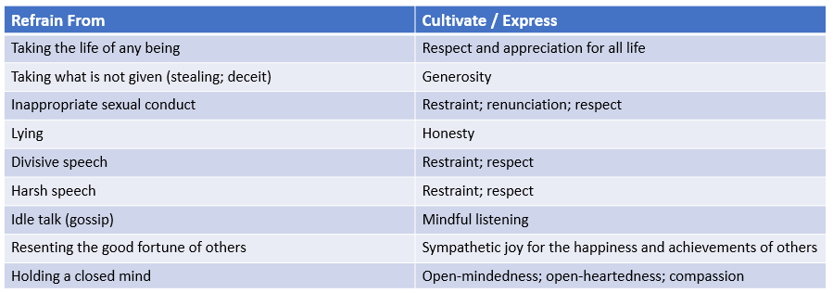

Turning the Wheel through Abandoning and Developing

Practicing with the Four Noble Truths

As we can see in the sutta excerpts, the Buddha applies each of the Four Noble Truths to each factor as a way of understanding it on the path to cessation. By doing so, he is applying careful, appropriate attention as a means of training and inclining the mind.

Here is a similar example from sutta MN 9 On Right View, trans. by Bhikkhu Bodhi:

“When, friends, a noble disciple understands craving [1; craving exists], the origin of craving [2], the cessation of craving [3], and the way leading to the cessation of craving [4], in that way he is one of right view… and has arrived at this true Dhamma."”

Here again are the Four Nobles:

- Dukkha (suffering/stress) exists (to be understood)
- Craving is the cause of suffering/stress (to be abandoned)
- There is a way out of suffering (to be realized)
- The way out is to practice the Noble Eight-fold path (to be developed)

Apply each noble truth to each condition while practicing:

- The [condition] is to be understood [what they feel like physically and mentally].
- This is the condition that gives rise to it; this is to be abandoned.
- There is a way to cease the [condition] which is to be realized.
- Apply steps of the Eightfold Path to cease suffering caused by the [condition].

In this way, we eventually, through investigation and practice, reach a place where:

- Suffering is understood.
- Craving and clinging have been abandoned.
- Cessation has been realized.
- We are liberated from suffering (perhaps just for a moment, or a few minutes, or in regard to a specific habitual pattern, a short time, a long time, or a lifetime).

Thich Nhat Hhan’s Five Mindfulness Trainings

If time allows, we’ll read the italicized sections; alternatively, these can be read at leisure.

“To practice the Five Mindfulness Trainings is to cultivate the insight of interbeing, or Right View, which can remove all discrimination, intolerance, anger, fear, and despair. If we live according to the Five Mindfulness Trainings, we are already on the path of a bodhisattva. Knowing we are on that path, we are not lost in confusion about our life in the present or in fears about the future.

Aware of the suffering caused by the destruction of life, I am committed to cultivating the insight of interbeing and compassion and learning ways to protect the lives of people, animals, plants, and minerals. I am determined not to kill, not to let others kill, and not to support any act of killing in the world, in my thinking, or in my way of life. Seeing that harmful actions arise from anger, fear, greed, and intolerance, which in turn come from dualistic and discriminative thinking, I will cultivate openness, non-discrimination, and non-attachment to views in order to transform violence, fanaticism, and dogmatism in myself and in the world.

Aware of the suffering caused by exploitation, social injustice, stealing, and oppression, I am committed to practicing generosity in my thinking, speaking, and acting. I am determined not to steal and not to possess anything that should belong to others; and I will share my time, energy, and material resources with those who are in need. I will practice looking deeply to see that the happiness and suffering of others are not separate from my own happiness and suffering; that true happiness is not possible without understanding and compassion; and that running after wealth, fame, power and sensual pleasures can bring much suffering and despair. I am aware that happiness depends on my mental attitude and not on external conditions, and that I can live happily in the present moment simply by remembering that I already have more than enough conditions to be happy. I am committed to practicing Right Livelihood so that I can help reduce the suffering of living beings on Earth and stop contributing to climate change.
True Love

Aware of the suffering caused by sexual misconduct, I am committed to cultivating responsibility and learning ways to protect the safety and integrity of individuals, couples, families, and society. Knowing that sexual desire is not love, and that sexual activity motivated by craving always harms myself as well as others, I am determined not to engage in sexual relations without true love and a deep, long-term commitment made known to my family and friends. I will do everything in my power to protect children from sexual abuse and to prevent couples and families from being broken by sexual misconduct. Seeing that body and mind are one, I am committed to learning appropriate ways to take care of my sexual energy and cultivating loving kindness, compassion, joy and inclusiveness – which are the four basic elements of true love – for my greater happiness and the greater happiness of others. Practicing true love, we know that we will continue beautifully into the future.
Loving Speech and Deep Listening

Aware of the suffering caused by unmindful speech and the inability to listen to others, I am committed to cultivating loving speech and compassionate listening in order to relieve suffering and to promote reconciliation and peace in myself and among other people, ethnic and religious groups, and nations. Knowing that words can create happiness or suffering, I am committed to speaking truthfully using words that inspire confidence, joy, and hope. When anger is manifesting in me, I am determined not to speak. I will practice mindful breathing and walking in order to recognize and to look deeply into my anger. I know that the roots of anger can be found in my wrong perceptions and lack of understanding of the suffering in myself and in the other person. I will speak and listen in a way that can help myself and the other person to transform suffering and see the way out of difficult situations. I am determined not to spread news that I do not know to be certain and not to utter words that can cause division or discord. I will practice Right Diligence to nourish my capacity for understanding, love, joy, and inclusiveness, and gradually transform anger, violence, and fear that lie deep in my consciousness.
Nourishment and Healing

Aware of the suffering caused by unmindful consumption, I am committed to cultivating good health, both physical and mental, for myself, my family, and my society by practicing mindful eating, drinking, and consuming. I will practice looking deeply into how I consume the Four Kinds of Nutriments, namely edible foods, sense impressions, volition, and consciousness. I am determined not to gamble, or to use alcohol, drugs, or any other products which contain toxins, such as certain websites, electronic games, TV programs, films, magazines, books, and conversations. I will practice coming back to the present moment to be in touch with the refreshing, healing and nourishing elements in me and around me, not letting regrets and sorrow drag me back into the past nor letting anxieties, fear, or craving pull me out of the present moment. I am determined not to try to cover up loneliness, anxiety, or other suffering by losing myself in consumption. I will contemplate interbeing and consume in a way that preserves peace, joy, and well-being in my body and consciousness, and in the collective body and consciousness of my family, my society and the Earth."

Closing Circle/Discussion

In May: Understanding the Deathless (Nibbana)

